3. Write a short essay (maximum 300 words) comparing the code you wrote in Problem 1 to the AI-generated code in Problem 2: What are the differences between your code and the AI-generated code? Is the AI-generated code better in any way? Is the AI-generated code worse in any way? Did you learn anything from the AI-generated code?

In this assignment, our group implemented the intermeans algorithm in MATLAB.
The manually written version (integration1.m) and the AI-generated version (integration2.m) were both used within the main function myintermeans_34.m.
The manual code was written completely by ourselves. It performs the histogram integration through explicit loops and variable updates, making it easy to debug and trace. The AI-generated code (integration2.m) was generated using Copilot during our discussion.
We decided together that integration2.m would represent the AI version because it was auto-completed by Copilot, and we verified its correctness manually afterward.
In comparison, the AI version is more concise and mathematically direct, but lacks readability and flexibility. The manually written one, though longer, shows clearer logic and safer data handling (e.g., type consistency, boundary checks). This discussion also shows that teamwork helped us better understand the strengths and weaknesses of AI-assisted coding.

4. Apply your function myintermeans_# to the image rice.png that is included in the MATLAB image processing toolbox. What value does myintermeans_# return?
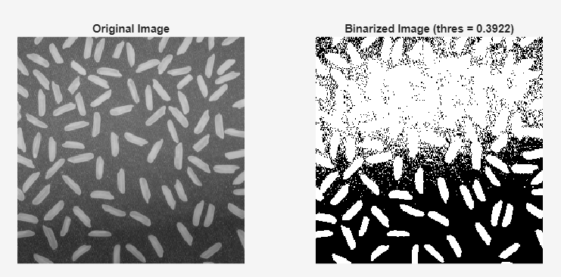
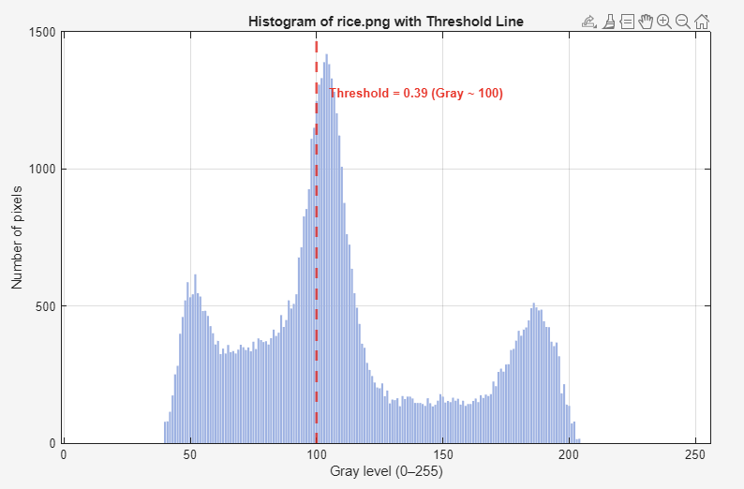
The intermeans threshold returned 0.3922 (≈100 gray level). The value lies between the dark background peak and the bright-grain peak in the histogram, consistent with the algorithm’s mean-driven update rule.
Due to strong illumination gradients in rice.png, the background contains a large portion of mid–high intensities, pulling the threshold left and producing white noise in brighter background regions. The result is algorithm-consistent, though not illumination-invariant.
5. Use the built-in MATLAB function im2bw to create a binary image bw using the threshold value determined in Problem 4 and look at bw using the imshow function. You should note that some grains of rice are lost in the binarization process. Why are they lost?
Using im2bw(im, thres) applies a single global threshold to the entire image. In rice.png the illumination is non-uniform (top region is brighter than the bottom), and the rice/background intensity distributions overlap. As a result, some rice pixels, especially those in shadowed or low-contrast areas, fall below the global threshold and are classified as background, so parts of grains (or entire small grains) are lost. In addition, texture/noise on the background can cross the threshold and create spurious white pixels, further breaking thin or dim grain regions.
6. Using the bwlabel function without the 2nd input argument, get MATLAB to count the number of rice grains in the binarized image bw generated in Problem 5. State what you typed at the MATLAB prompt to calculate the number of grains. State how many grains were counted. Hint: I want you to become accustomed to using the help command.
Used prompts:
help bwlabel
[L, num] = bwlabel(bw);
Counted grains:
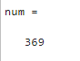
7. There will be some spots in the binarized image bw that do not correspond to actual rice grains but arise because of noise in the image. Using the help command, give a brief summary (i.e., no more than 3 sentences; no run-on sentences) of what the command bwareaopen does. Using the 2-argument version of the bwareaopen command, apply it to the binary image bw to produce another binarized image called bw2 in which these spots are mostly eliminated; use 5 for the second input argument. Using bwlabel, count the number of grains and state it in your submission.
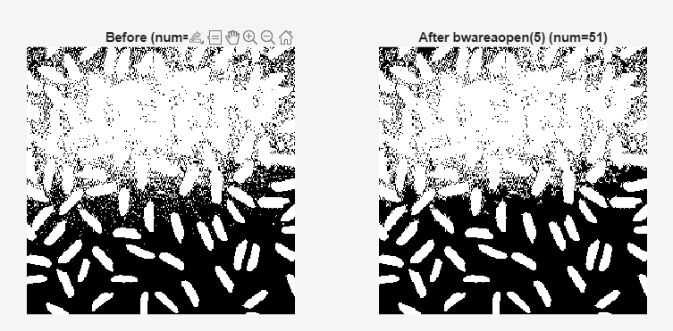
bwareaopen removes small connected components from a binary image. It deletes all objects with fewer than P pixels (8-connectivity for 2-D by default) and returns a cleaned binary image. It is commonly used to suppress salt-and-pepper noise and tiny specks.
Commands used:
[L, num ] = bwlabel(bw); % count before
bw2 = bwareaopen(bw, 5); % remove components with area < 5 pixels
[L2, num2] = bwlabel(bw2); % count after

Resuls:
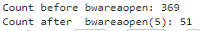

Most tiny noise blobs and broken fragments (area < 5 px) were removed, so the number of labeled components dropped substantially; remaining labels correspond more closely to actual rice grains.

